Final Race Instructions
Its Grim up North Running – Ruddy Rothwell Cakeathon

GOVERNING BODY: The Trail Running Association

Sunday 2nd July

RACE HEADQUARTERS:

Leeds Skelton Lake Services, M1 Junction 45, Leeds, LS9 0AS
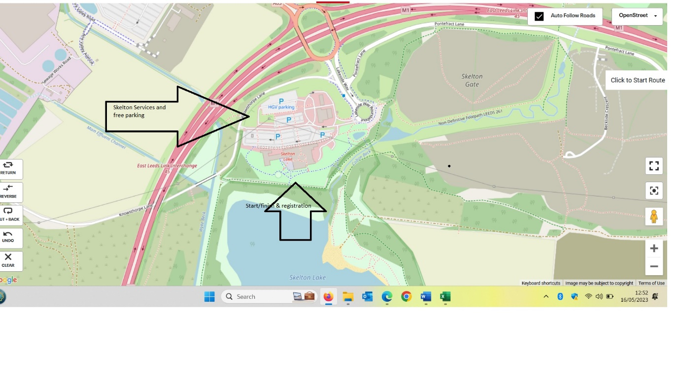
GETTING TO US AND PARKING

Parking is free, there will be a marshal from 07:45 to point you in the right direction.

FACILITIES

Toilets are available within the services.

GRIM MASSAGE

Adam will be available for both pre-race and post-race massage. He his brilliant. You can pay by either cash or card.

REGISTRATION

Distance | Registration opens | Start
Early Bird Ultra & Marathon only – upon request | 07:40 | 08:30
Ultra | 07:45 | 09:30
Marathon | 07:45 | 09:30
20 Miler | 07:45 | 09:30
15 Miler | 07:45 | 09:30
10 Miler | 07:45 | 09:30
5 Miler | 07:45 | 09:30

BAGGAGE DROP

There will be a baggage drop, in the Grim van which will be available at the start and finish area.

THE ROUTE

The route is measured by Plot-a-route and Garmin. The route is a 5-mile loop.

5 Mile loop - https://www.plotaroute.com/route/2251663

The course is a 5-mile loop and is generally good underfoot, especially if the weather is dry.
The courses will be marshalled and signed.
There will be a feed station approximately halfway around the loop.

RACE SHOES

Weather dependant – if wet trail shoes.

DURING THE RACE

Please do not litter, take all gel wrappers etc with you or leave with a marshal.

We hope to start all the races promptly. Please inform a race official if you are unable to complete the course and need to withdraw for any reason, please hand your race number to the official. Please assist officials by making sure your number is visible. Always wear your race number on the front of your vest.

Please be aware of all other users of the country park and be kind and courteous.

THE RACE

The race starts and finishes in the same place.

WATER AND FEED STATIONS

This is cupless event. All runners are requested to bring their own labelled, reusable cup or bottle. We are happy to fill your bottles before, during and after the event. We’ll have feed stations every 2.5 miles. We’ll provide water, squash, cola as well as crisps and savoury snacks. Please use the bins provided. If you don’t have your own bottle/cup, we sell reusable, squashable cups for £5.

HEADPHONES
We do not want to spoil the enjoyment of the event for the competitors, but we do not endorse the use of MP3 players, or similar devices, for the following safety reasons:
Runners cannot always hear the marshals’ instructions.
Runners may not hear cyclists behind them and stray into their path.
Bone conduction earphones are allowed.

YOUR REWARD AT THE END

Huggins of Hugs
Bespoke medal
All our events have lots of lovely things at the finish line. As we love to celebrate every runners’ achievements. All our runners are winners.

WEATHER

Please keep an eye on the forecast and dress appropriately.

GRIM Looks forward to welcoming you next week.

